Brute Force Algorithm for Finding the Nearest Weather Monitoring Stations
Aim
To implement the brute-force algorithm that compares all pairs of weather station coordinates to determine the nearest stations.

Problem Statement
A weather monitoring system stores coordinates of multiple weather stations. The objective is to determine the nearest pair of stations by comparing every possible pair using the brute-force method.

Algorithm
- Store coordinates of all weather stations.
- Initialize the minimum distance with a large value.
- Compare every station with every other station.
- Compute the Euclidean distance.
- If a smaller distance is found, update the minimum distance.
- Print the nearest pair.
Explanation
The brute-force algorithm checks every possible pair of weather stations.
If there are n stations, then
- Station 1 is compared with all remaining stations.
- Station 2 is compared with stations after it.
- This continues until all possible pairs are examined.
The Euclidean distance formula is
$$Distance=\sqrt{{\left(x_{2}-x_{1}\right)}^{2}+{\left(y_{2}-y_{1}\right)}^{2}}$$
The smallest distance obtained is considered the nearest pair.

a) Explain how all pairs are evaluated.
The brute-force algorithm compares every weather station with every other station exactly once.
For example, if there are five stations:
A
B
C
D
E
The comparisons are
A-B
A-C
A-D
A-E

B-C
B-D
B-E

C-D
C-E

D-E
Each comparison calculates the Euclidean distance. After all comparisons are completed, the pair with the minimum distance is selected.

(b) Derive the Time Complexity
If there are n stations, the number of comparisons is
$$\frac{n\left(n-1\right)}{2}$$
This simplifies to
$$O\left(n^{2}\right)$$
Therefore,
Time Complexity = O(n²)
Space Complexity:
Only a few variables are used.
$$O\left(1\right)$$

(c) Inefficiency for Large-Scale Systems
Although the brute-force algorithm is simple and guarantees the correct result, it becomes inefficient when the number of weather stations increases.
For example:
Stations | Comparisons
100 | 4,950
1,000 | 499,500
10,000 | 49,995,000
As the number of stations grows, the number of comparisons increases rapidly, resulting in longer execution time. Therefore, brute force is not suitable for large-scale weather monitoring systems.
More efficient algorithms such as the Divide and Conquer Closest Pair Algorithm can solve the problem in O(n log n) time.

Source Code
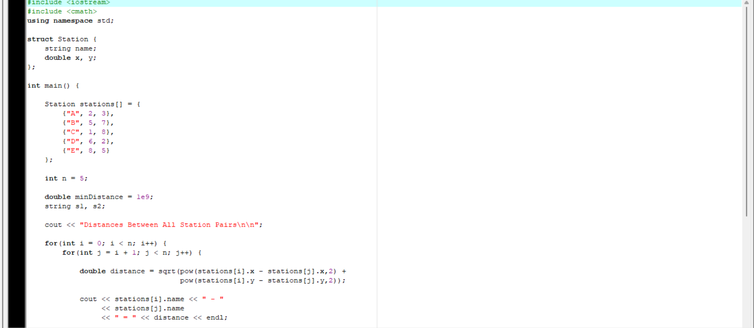Output
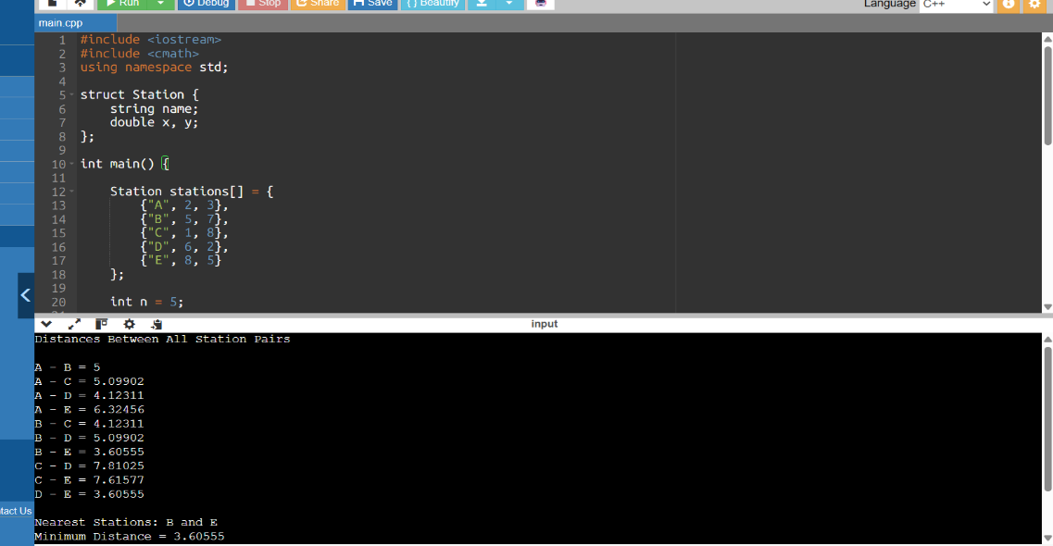

Analysis
Advantages
- Easy to understand and implement.
- Always finds the correct nearest pair.
- Suitable for small datasets.
Disadvantages
- Requires comparing every possible pair.
- Execution time grows quadratically.
- Not efficient for thousands of weather stations.

Conclusion
The brute-force algorithm successfully identifies the nearest weather stations by comparing every possible pair of coordinates. It is appropriate for small datasets because of its simplicity and correctness. However, its O(n²) time complexity makes it inefficient for large-scale weather monitoring systems, where more advanced algorithms such as Divide and Conquer provide significantly better performance.

